Salon and Spa Requirements Specification

11 June , 2024

Use this Requirements Specification template to document the requirements for your product or service, including priority and approval. Tailor the specification to suit your project, organizing the applicable sections in a way that works best, and use the checklist to record the decisions about what is applicable and what isn't.

The format of the requirements depends on what works best for your project.

This document contains instructions and examples which are for the benefit of the person writing the document and should be removed before the document is finalized.

To regenerate the TOC, select all (CTL-A) and press F9.

**Table of Contents**

**Beauty and Spa REQUIREMENTS SPECIFICATION 1**

**VERSION 1.0 1**

**APRIL 19, 2021 1**

**1.** **EXECUTIVE SUMMARY 3**

1.1 Project Overview 3

1.2 Purpose and Scope of this Specification 3

**2.** **PRODUCT/SERVICE DESCRIPTION 3**

2.1 Product Context 3

2.2 User Characteristics 3

2.3 Assumptions 3

2.4 Constraints 3

**3.** **REQUIREMENTS 4**

3.1 Functional Requirements 5

3.2 Non-Functional Requirements 5

*3.2.1* *Product Requirements 5*

**3.2.1.1** **User Interface Requirements** 6

**3.2.1.2** **Usability** 6

**3.2.1.3** **Efficiency** 6

3.2.1.3.1 Performance Requirements 6

3.2.1.3.2 Space Requirements 6

**3.2.1.4** **Dependability** 6

**3.2.1.5** **Security** 7

*3.2.2* *Organizational Requirements 7*

**3.2.2.1** **Environmental Requirements** 7

**3.2.2.2** **Operational Requirements** 7

**3.2.2.3** **Development Requirements** 7

*3.2.3* *External Requirements 7*

**3.2.3.1** **Regulatory Requirements** 7

**3.2.3.2** **Ethical Requirements** 7

**3.2.3.3** **Legislative Requirements** 7

3.2.3.3.1 Accounting Requirements 7

3.2.3.3.2 Security Requirements 7

3.3 Domain Requirements 7

**4.****1****USER SCENARIOS/USE CASES 7**

4.1.1 *Extended User Scenarios*

4.1.2 User Cases

4.1.3 *User Cases Extended*

**4.2 Behavioral Diagrams**

**4.2.1 Use Case diagram**

**4.2.2 Activity diagrams**

**4.3 ERD SCHEMA**

**4.3.2 RelationalSchema**

**4.4 Class Diagram**

**4.5 Component diagram**

**4.6 Sequence diagram**

**5. Program Visualised**

**6. Gantt Chart**

# Executive Summary

## Project Overview

In today’s fast-paced digital era, technology is revolutionizing industries across the board—including the beauty and wellness sector. The Salon and Spa Management System is a modern solution aimed at transforming how salon and spa businesses operate by digitizing and automating their core services and administrative processes.

Traditionally, salons and spas have relied on manual booking logs, paper-based customer records, and verbal communications for managing appointments, inventory, and staff schedules. These outdated methods are often time-consuming, error-prone, and inefficient, especially as customer expectations grow for faster and more convenient services.

Our system addresses these challenges by providing a centralized, user-friendly platform that enables:

* Customers to browse available services, book appointments online, and receive automated reminders;
* Staff to manage their schedules, access appointment details, and update service statuses in real-time;
* Administrators to oversee business operations, manage inventory, generate performance reports, and ensure a seamless customer experience.

The solution is designed to serve small to mid-sized salons and spas looking to modernize their operations, enhance customer satisfaction, and improve overall business efficiency. It supports integration with popular communication and payment gateways, allowing for real-time updates, secure transactions, and automated notifications.

This project contributes to the digital transformation of the personal care industry by eliminating paperwork, reducing administrative burden, and enabling businesses to focus more on delivering high-quality service. Ultimately, it empowers both customers and professionals with tools that are intuitive, efficient, and reliable.

## Purpose and Scope of this Specification

The purpose of this specification document is to formally define the functional and non-functional requirements for the Salon and Spa Management System. This specification will serve as a foundational reference for all stakeholders involved in the design, development, deployment, and validation of the system, including developers, project managers, testers, and end-users.

The objective of the software is to streamline the daily operations of a salon and spa by digitizing essential processes such as appointment scheduling, service management, customer profiling, inventory tracking, and billing. By offering a web-based solution, the system will facilitate efficient interaction between customers, staff, and administrative personnel, thereby enhancing service delivery and operational control.

In addition to automating business workflows, the system will also provide customers with access to their appointment history and preferences, while allowing staff to manage their schedules and services with greater ease. The platform emphasizes both usability and data security, ensuring transparency in operations and protection of personal and transactional information.

This documentation is intended for all potential users of the system, including technical and non-technical personnel. It offers a detailed description of system functionalities, interface expectations, and operational behaviors.

**In Scope:**

* Online customer registration and login.
* Appointment booking and rescheduling.
* Service catalog management.
* Staff scheduling and availability tracking.
* Billing, payments, and invoice generation.
* Inventory monitoring and restock alerts.
* Feedback submission and reporting tools.
* Notification system for reminders and promotions.

**Out of Scope:**

* Development of mobile applications (this phase focuses on a web-based solution).
* Integration with third-party accounting platforms.
* Payroll management for salon staff.
* Loyalty point systems and marketing campaign automation.

# Product/Service Description

The Salon and Spa industry plays a significant role in today’s service economy by promoting personal care, wellness, and relaxation. However, many small to mid-sized salon and spa businesses still rely on manual and paper-based systems for appointment scheduling, service management, customer records, and inventory tracking. These outdated processes can lead to inefficiencies, booking errors, poor customer experiences, and administrative overhead.

As customer expectations evolve and demand for seamless, tech-enabled services increases, salon and spa businesses are under pressure to modernize their operations. The need for a digital transformation in this sector has become more evident, especially with the growing reliance on online services and contactless interactions.

The Salon and Spa Management System addresses these challenges by offering a centralized and intuitive web-based platform tailored specifically for salons and spas. The system is designed to support key business functions such as online appointment scheduling, customer relationship management, staff coordination, service cataloging, billing, and inventory oversight.

This platform accommodates multiple user roles, including:

* Customers, who can book services and manage their profiles;
* Staff, who can view schedules, update service statuses, and track daily appointments;
* Administrators, who can manage services, employees, generate reports, and monitor system-wide activities.

By automating and digitizing day-to-day tasks, the system reduces reliance on manual documentation and minimizes the risk of human error. It also enhances customer satisfaction through better service personalization, real-time updates, and streamlined communication.

The system is developed as a web application using modern web technologies and follows object-oriented design principles to ensure scalability, maintainability, and security. It is a critical step forward in aligning salon and spa businesses with the digital expectations of today’s consumers.

## Product Context

The Salon and Spa Management System is designed to be an independent, self-contained web-based application that caters specifically to the operational needs of salon and spa businesses. It is not dependent on any existing enterprise software or external platform to perform its core functions, although it is built with the flexibility to integrate with third-party services for added functionality.

The system serves three main user groups: customers, staff members, and administrators. Each of these users interacts with the system through personalized interfaces that support their respective roles. While the system is largely autonomous, it supports external integrations in the following key areas:

* Payment Gateways**:** Integration with third-party payment processors (e.g., Stripe, PayPal) allows customers to complete transactions securely and conveniently.
* Notification Services**:** SMS and email notification APIs are used to send automated appointment reminders and promotional offers to customers.
* Calendar Synchronization (Optional): The platform can offer synchronization with Google Calendar or similar tools for staff and customer scheduling.
* Data Export for Analysis: Business owners may export reports in standard formats (e.g., PDF, Excel) for external analysis or financial documentation.

Although not intended to directly connect with other salon systems, the platform includes functionality for data portability. This enables the export of customer records and service history in case the business transitions to another system or adopts a broader enterprise platform in the future.

In summary, the system is modular, extensible, and scalable—capable of operating independently while being compatible with essential external services that enhance the user experience and business operations.

## User Characteristics

The Salon and Spa Management System is designed to be accessed by three distinct types of users: Customers, Staff Members, and Administrators. Each user profile presents varying levels of access, responsibilities, and technical expectations. The system has been developed with these user characteristics in mind to ensure a user-friendly experience and role-appropriate functionality.

1. Customer

* + Prefers a responsive and visually appealing interface.
  + Expects quick and convenient booking and cancellation of appointments.
  + Interested in receiving notifications and viewing appointment history.
  + May seek options to leave service feedback or rate experiences.

2. Staff Member (Service Provider / Therapist / Stylist)

* + Requires intuitive scheduling tools.
  + Needs access to daily/weekly appointment lists and service details.
  + Should be able to update availability and customer service notes.
  + Expects a system that is fast and reliable during high-volume business hours.

3. Administrator / Manager

* + Requires access to detailed service analytics and staff performance metrics.
  + Needs to manage user accounts, services, inventory, and promotional campaigns.
  + Expects high data integrity, security, and easy access to logs or audit trails.
  + Responsible for handling sensitive operations and ensuring proper system usage across the business.

## Assumptions

The development and deployment of the Salon and Spa Management System are based on the following assumptions:

* It is assumed that salon staff and administrators will receive adequate training on using the system to perform their roles effectively and avoid misuse.
* It is assumed that customers will have basic digital literacy and access to the internet, allowing them to interact with the web platform without the need for training.
* It is assumed that the system will be deployed on secure and reliable hosting infrastructure, with regular maintenance and support available to ensure system availability.
* It is assumed that each staff member will be assigned a personal account by the administrator. Only authorized personnel can create, deactivate, or modify staff profiles.
* It is assumed that user authentication and role-based permissions will be strictly enforced to ensure data confidentiality and system integrity.
* It is assumed that all service-related activities (appointment creation, service completion, billing) will be recorded in the system in real time by the responsible staff.
* It is assumed that only authorized administrators can manage core system configurations, such as pricing updates, service additions, or report generation modules.
* It is assumed that the internet connection at the salon/spa premises will be stable, as the system requires internet access to function effectively.
* It is assumed that third-party services (such as payment gateways and notification APIs) used by the system will remain functional and accessible during standard operations.

**2.4 Constraints**

The system must operate within the following constraints:

* The platform will be a web-based application, which requires a stable internet connection for all real-time operations, including accessing the database, processing transactions, and sending notifications.
* System access is restricted to authorized roles: Customers have limited access to their personal information and booking functions; staff and administrators have broader access based on their responsibilities.
* Hardware dependency: All staff (including front desk personnel and service providers) are expected to use internet-connected computers or tablets during working hours to interact with the system.
* The application’s features, such as Google Maps integration (for location-based service discovery or directions), email notifications, and payment verification, rely on the continuous availability of external web services.
* Data privacy regulations must be respected. Personal data and booking information must only be accessible to the corresponding customer and relevant authorized staff.
* System updates or maintenance may require temporary service interruptions, which should be scheduled during off-peak hours and communicated in advance.

## Dependencies

Since the administrator (salon manager) and staff members play key coordinating roles within the system, several operational dependencies exist between different types of users:

Between Administrator and Staff/Customer:

* No new staff member or customer profile can be created unless the administrator is registered and logged into the system.
* Staff or customer profiles cannot be updated or deleted without administrative authorization.
* Service listings, pricing, and scheduling availability must be configured by the administrator before staff or customers can engage with them.
* Reports and inventory data cannot be generated or accessed unless the administrator has set up the relevant modules.

Between Staff and Customer:

* Customers cannot be serviced unless a staff member is assigned to the corresponding appointment.
* Appointment records and service notes cannot be created unless the service provider completes and submits the form.
* Customers cannot view their completed service history unless the staff member has confirmed the appointment and saved the related information.
* System-Level Dependencies:
* Notifications (e.g., reminders or confirmations) will not be sent unless the third-party notification service is integrated and active.
* Online payments cannot be processed unless the system is connected to an approved payment gateway.
* The system cannot be used without a stable internet connection and access to the hosted server.

These dependencies emphasize the importance of coordination and role-based access in ensuring the system functions efficiently and securely.

## 3.1 Functional Requirements

|  |  |  |  |  |  |
| --- | --- | --- | --- | --- | --- |
| Req# | Requirement | Comments | Priority | Date | Reviewed / Approved |
| FR_01 | The software should have different views for different user roles. | Different interfaces for customers, staff, and administrators. | 2 | 27/03/2025 |  |
| FR_02 | User accounts must be secured with passwords. | Passwords will be encrypted in the system database. | 1 | 27/03/2025 |  |
| FR_03 | Staff should be able to manage daily service schedules. | Includes checking appointments and updating status. | 2 | 27/03/2025 |  |
| FR_04 | Admin should be able to add or remove services from the list. | Allows dynamic service management. | 2 | 27/03/2025 |  |
| FR_05 | The system must support user registration and login. | Users should be able to create accounts and authenticate using secure credentials. | 1 | 27/03/2025 |  |
| FR_06 | The system should send automated email/SMS notifications. | Notifications for appointment confirmations, reminders, and feedback requests. | 2 | 27/03/2025 |  |
| FR_07 | Administrators should be able to generate business performance reports. | Reports include revenue trends, staff performance, and service popularity. | 2 | 27/03/2025 |  |
| FR_08 | Staff should be able to view and manage their own schedules. | Allows service providers to check availability and upcoming appointments. | 2 | 27/03/2025 |  |
| FR_09 | Customers should be able to view service history and feedback status. | Includes list of past appointments and any submitted feedback. | 2 | 27/03/2025 |  |
| FR_10 | Admins should be able to update pricing and service descriptions. | For modifying rates and details without needing developer involvement. | 2 | 27/03/2025 |  |
| FR_11 | The system should provide feedback functionality after service completion. | Customers can rate and review services to improve quality. | 2 | 27/03/2025 |  |
| FR_12 | The system must validate data inputs to prevent invalid entries. | Form validation to ensure correct formats (e.g., email, phone). | 1 | 27/03/2025 |  |
| FR_13 | All transactions should be logged for security and audit purposes. | Includes booking, payments, and updates for traceability. | 1 | 27/03/2025 |  |
| FR_14 | The system must allow exporting reports in PDF or Excel format. | Supports external reporting or offline analysis by management. | 2 | 27/03/2025 |  |
| FR_15 | Admins should be able to assign roles and permissions. | For limiting access based on user roles (staff, admin, customer). | 1 | 27/03/2025 |  |

## 

## 3.2 Non-Functional Requirements

## 3.2.1.1 User Interface Requirements

The system interface shall be responsive and accessible via both desktop and mobile browsers. The layout will include clearly defined sections for navigation, appointment booking, service selection, and user profile management. Menus should be intuitive, and error messages must be user-friendly, descriptive, and non-technical. Report layouts will be printable and downloadable in PDF or Excel formats.

### 3.2.1.2 Usability

The system shall prioritize user-centered design and be easy to learn without formal training. Help documentation shall be embedded within the system and context-sensitive. Tooltips, guided tours, and an FAQ section shall assist users with common tasks. The platform must support accessibility guidelines to ensure usability for users with visual or mobility impairments.

### 3.2.1.3 Efficiency

#### 2.6.1.3.1 Performance Requirements

• The system shall support up to 100 concurrent users without degradation in performance.  
• 95% of transactions shall be completed in under 2 seconds under normal operating conditions.  
• Appointment bookings shall be processed within 1 second during peak hours.  
• Monthly reports with up to one year of data must be generated within 5 seconds.

#### 2.6.1.3.2 Space Requirements

• The system shall use no more than 500MB of server space per year for storing user and transactional data.  
• Each report file shall not exceed 2MB in size.

### 3.2.1.4Dependability

• The system shall be operational 24/7, except for scheduled maintenance windows.  
• It shall achieve 99.5% uptime monthly.  
• Monitoring tools will alert the administrator to system failures or anomalies in real-time.  
• The system shall allow for error logging and diagnosis through built-in monitoring dashboards.

• The system shall support modular architecture to allow updates without affecting core functionalities.  
• Failures must be recoverable with minimal manual intervention.  
• Backup and restore operations must complete within 60 minutes.

• The system shall enforce data validation and integrity rules across all modules.

### 3.2.1.5 Security

• All data transmission shall be encrypted using TLS.  
• The system shall support user authentication and role-based authorization.  
• Activity logs and historical data shall be maintained for auditing purposes.  
• Intermodule communications shall be protected against unauthorized access.  
• Data integrity checks shall be performed on all user inputs and transaction records.

## 2.6.2 Organizational Requirements

### 2.6.2.1 Environmental Requirements

The application shall operate reliably in cloud-hosted environments supporting modern web browsers (Chrome, Edge, Firefox, Safari).

### 2.6.2.2 Operational Requirements

The system must align with salon operational hours and automatically restrict access to appointment scheduling outside those hours.

### 2.6.2.3 Development Requirements

The system shall be developed using modular, maintainable code adhering to secure coding practices. Code must be documented and follow industry standards to facilitate scalability and third-party audits.

## 3.2.2 External Requirements

### 3.2.2.1 Regulatory Requirements

The system must comply with international data protection laws such as GDPR. All data collection and storage must have documented user consent.

### 3.2.2.2 Ethical Requirements

The system must not collect, share, or utilize user data for purposes outside of service delivery and support. Customer feedback and service ratings must be anonymized to protect user identity.

### 3.2.2.3 Legislative Requirements

• Changes to records must be logged with before-and-after snapshots.  
• Exported reports must follow industry formatting standards for accounting.  
• All user activity affecting sensitive data must be audited and stored in compliance logs.

#### 3.2.2.3.1 Accounting Requirements

The billing module must support generation of transaction histories, refunds, discounts, and payment status logs in PDF or Excel formats for accounting review.

#### 3.2.2.3.2 Security Requirements

All access to customer and financial data must be protected with two-factor authentication and limited by user role.

## 3.3 Domain Requirements

This web-based application operates within the Salon and Spa industry, where efficient management of customer appointments, service records, and staff coordination is critical to ensuring smooth business operations and high customer satisfaction. The system aims to digitize and centralize salon operations, enabling streamlined service delivery and business insights through integrated features such as booking, billing, feedback, and reporting.

A core domain-specific concern in this application is the protection of customer data and transactional integrity. Since the system handles sensitive information—such as customer contact details, appointment history, and payment data—data security and controlled access are paramount. Only registered users with authenticated roles (e.g., administrator, staff, or customer) should have access to relevant system functionalities.

This application is intended to be deployed within individual salons or spa branches and is expected to run on secured local or cloud-based networks. While it may interface with third-party services (e.g., payment gateways or notification providers), the system does not require direct communication with external enterprise software systems such as ERP or CRM platforms in its initial version.

All domain-specific functionality—such as service catalog management, employee scheduling, and appointment workflows—must conform to the operational logic and business practices typical of salon and spa environments.

.These domain requirements ensure the system is tightly aligned with the real-world workflows and challenges of the personal care industry, while maintaining a focus on efficiency, usability, and data privacy.

# **4.1 User Scenarios/Use Cases**

|  |  |  |
| --- | --- | --- |
| Nr | Name | Description |
| US_01 | User logs in | Customers, staff, and administrators log in using their username and password. |
| US_02 | Change password | Any user can securely change their password after logging in. |
| US_03 | Customer registration | A new customer creates an account to access booking and feedback features. |
| US_04 | Book appointment | Customer selects a service, staff, and available time to book an appointment. |
| US_05 | Cancel/reschedule appointment | Customer modifies or cancels a previously booked appointment. |
| US_06 | View available services | Customer browses the list of salon and spa services. |
| US_07 | Admin manages service list | Admin adds, updates, or deletes services offered. |
| US_08 | Manage staff | Admin adds new staff members, updates their profiles, or removes them from the system. |
| US_09 | Staff views schedule | Staff member views upcoming appointments assigned to them. |
| US_10 | Staff updates service status | Staff marks appointment as completed or updates service notes. |
| US_11 | Admin generate reports | Admin generates reports on revenue, service usage, and staff performance. |
| US_12 | Admin manage inventory | Admin monitors and updates product stock levels. |
| US_13 | Submit feedback | Customer rates and comments on completed services. |
| US_14 | Receive notifications | Customer receives appointment reminders and promotional messages via email/SMS. |
| US_15 | View appointment history | Customer checks past bookings and completed services. |
| US_16 | Staff profile management | Staff updates their working hours and personal details. |
| US_17 | Admin role assignment | Admin assigns or changes roles and access permissions for users. |
| US_18 | Admin views reports | Admin exports reports as PDF or Excel files for record-keeping or analysis. |
| US_29 | Logout | Any user securely logs out of their account. |



**4.1.1** **Extended User Scenarios**

1. **US_01 – User logs in**

1. User selects user type: customer/staff/admin

2. User is redirected to the login page

3. User enters username and password

4. User submits credentials

5. System authenticates and redirects to the respective dashboard

6. If login fails, an error message is displayed

1. **US_02 – Change password**

1. User logs in and navigates to the change password section

2. User enters current password and new password twice

3. System validates password format and match

4. System updates the password if validations pass

5. User receives confirmation or error message

### ****3. US_03 – Customer registration****

1.User opens the registration page

2.User enters name, email, phone, and password

3.User submits the registration form

4.System validates inputs and creates an account

5.Confirmation message or error is displayed

**4. US_04 – Book appointment**

1.Customer logs in

2.Customer navigates to booking page

3.Customer selects service, staff, date, and time

4.Customer confirms booking

5.System saves the appointment and sends confirmation notification

### ****US_05 – Cancel/Reschedule Appointment****

1.User logs in and is redirected to the customer dashboard

2.User navigates to the "My Appointments" or "Appointment History" section

3.User selects an upcoming appointment to cancel or reschedule

4.System displays appointment details with options: Cancel | Reschedule

5.If Cancel is selected:

 a. User confirms cancellation

 b. System updates appointment status to "Cancelled"

 c. System notifies staff via email/SMS

6.If Reschedule is selected:

 a. User selects a new date, time, or staff (if allowed)

 b. System checks availability

 c. User confirms the new appointment

 d. System updates appointment details and notifies staff

7.System displays a success message and updates the appointment list

If operation fails, an error message is shown (e.g., slot unavailable, system error).

**6. US_06 – View available services**

1.Customer visits the services section

2.System displays a list of all available services with details

3.Customer browses through the services

**7. US_07 – Admin Manages service list**

1.Admin logs in and navigates to service management

2.Admin adds, updates, or deletes services

3.System validates input and updates the database

4.System confirms successful action or displays error

**8. US_08 – Admin manages staff**

1.Admin logs in and goes to staff management section

2.Admin adds new staff member with details

3.Admin may update existing staff profiles

4.Admin may delete staff from the system

5.System reflects changes accordingly

**9. US_09 – Staff views schedule**

1.Staff logs in and goes to schedule page

2.System retrieves appointments assigned to the staff

3.Staff views daily or weekly schedule

**10. US_10 – Staff updates service status**

1.Staff logs in and selects a completed appointment

2.Staff updates service notes or marks it as completed

3.System records the updates and reflects status

**11. US_11 – Admin generate reports**

1.Admin logs in and navigates to reports section

2.Admin selects report type: revenue, services, or staff performance

3.Admin chooses the time period

4.System generates the requested report

5.Report is displayed for viewing

**12. US_12 – Admin manages inventory**

1. Admin logs in and navigates to the inventory management section.

2. Admin views the list of all products, including stock quantity and usage rate.

3. Admin selects a product to update.

4. Admin can increase/decrease stock, edit product details, or mark items as out of stock.

5. System validates the input and updates the database accordingly.

6. System shows a confirmation message or displays an error if the action fails.

7. Updated inventory reflects in service preparation or staff view if linked.

**13. US_13 – Submit feedback**

1.Customer logs in and navigates to feedback section

2.Customer selects rating and enters comment

3.Customer submits feedback

4.System saves feedback and updates statistics

14. US_14 – Receive notifications

1.Customer books or updates an appointment

2.System checks for scheduled reminders or promotions

3.Notification is generated and sent via email/SMS

4.Customer receives the notification

**15. US_15 – View appointment history**

1.Customer logs in and navigates to appointment history

2.System retrieves past completed appointments

3.Customer reviews service details and dates

**16. US_16 – Admin role assignment**

1.Admin logs in and accesses user management

2.Admin selects a user to modify

3.Admin assigns or changes role (customer, staff, admin)

4.System updates user permissions

**17. US_17 – Admin views reports**

1.Admin generates a report (revenue, services, performance)

2.Admin clicks the export option

3.Admin selects format (PDF or Excel)

4.System processes and downloads the report

**18. US_18 – Logout**

1.User clicks logout button

2.System ends session and redirects to homepage

**4.1.2 User Cases**

|  |  |
| --- | --- |
| Element | Description |
| Name | **User logs in** |
| Summary | **User enters personal information to access their account.** |
| Actor | **Customer / Staff / Administrator** |
| Description | **User gains access to their account after entering the correct credentials.** |
| Precondition | **Active account and role selection required.** |
| Alternatives | **One account per session; users with multiple roles use separate accounts.** |
| Postcondition | **User is redirected to their dashboard.** |

**UC_01-US_01 – User logs in**

|  |  |
| --- | --- |
| Element | Description |
| Name | **Change password** |
| Summary | **User changes their password.** |
| Actor | **Customer / Staff / Administrator** |
| Description | **Enters current and new passwords; system verifies and updates.** |
| Precondition | **User logged in; old password correct; validation rules passed.** |
| Alternatives | **User retries if validation fails.** |
| Postcondition | **New password is saved.** |

**UC_02-US_02– Change password**

|  |  |
| --- | --- |
| Element | Description |
| ****Name**** | Customer registration |
| ****Summary**** | A new customer signs up for access to booking and feedback features. |
| ****Actor**** | Customer |
| ****Description**** | User fills out a registration form with personal information. |
| ****Precondition**** | Registration page must be accessible. |
| ****Alternatives**** | Duplicate emails are not allowed; validation errors prompt correction. |
| ****Postcondition**** | Account is created and user receives confirmation. |

**UC_03-US_03-Customer registration**

**UC_04 – US_04: Book Appointment**

|  |  |
| --- | --- |
| Element | Description |
| ****Name**** | Book appointment |
| ****Summary**** | Customer books an appointment with chosen service, staff, and time. |
| ****Actor**** | Customer |
| ****Description**** | Customer selects desired service, staff member, and time slot to make a booking. |
| ****Precondition**** | Customer must be logged in and services must be available. |
| ****Alternatives**** | Time conflicts or unavailable staff prompt re-selection. |
| ****Postcondition**** | Appointment is saved and confirmation is sent. |

|  |  |
| --- | --- |
| Element | Description |
| Name | **Cancel/Reschedule Appointment** |
| Summary | **Customer modifies or cancels an existing booking.** |
| Actor | **Customer** |
| Description | **User accesses their appointment history and either cancels or reschedules an appointment.** |
| Precondition | **Customer must be logged in and have existing appointments.** |
| Alternatives | **If rescheduling fails due to availability, system notifies the user to choose again.** |
| Postcondition | **Appointment is updated or cancelled, and staff are notified.** |

**UC_05 – US_05: Cancel/Reschedule Appointment**

|  |  |
| --- | --- |
| Element | Description |
| Name | **View available services** |
| Summary | **Customer views the list of salon and spa services offered.** |
| Actor | **Customer** |
| Description | **Customer browses through the list of services along with descriptions and prices.** |
| Precondition | **Services must be published in the system.** |
| Alternatives | **Services may be filtered by category or duration.** |
| Postcondition | **Customer is informed of available service options.** |

**UC_06 – US_06: View Available Services**

|  |  |
| --- | --- |
| Element | Description |
| Name | **Admin manages service list** |
| Summary | **Admin adds, edits, or removes services from the system.** |
| Actor | **Administrator** |
| Description | **Admin performs CRUD operations on the service list to maintain up-to-date offerings.** |
| Precondition | **Admin must be logged in.** |
| Alternatives | **Input validation ensures no duplicate or incomplete entries.** |
| Postcondition | **Services are updated in the system and reflected to users.** |

**UC_07 – US_07: Admin Manages Service List**

|  |  |
| --- | --- |
| Element | Description |
| Name | **Admin manages staff** |
| Summary | **Admin adds, edits, or removes staff profiles.** |
| Actor | **Administrator** |
| Description | **Admin maintains staff records including names, roles, and availability.** |
| Precondition | **Admin must be logged in.** |
| Alternatives | **Deleted staff cannot be assigned new appointments.** |
| Postcondition | **Staff list reflects the latest updates.** |

**UC_08 – US_08: Admin Manages Staff**

|  |  |
| --- | --- |
| Element | Description |
| Name | **Staff views schedule** |
| Summary | **Staff views their upcoming appointments.** |
| Actor | **Staff** |
| Description | **Staff accesses their schedule to view daily or weekly bookings.** |
| Precondition | **Staff must be logged in.** |
| Alternatives | **Schedule can be viewed in list or calendar format.** |
| Postcondition | **Staff is informed of their assigned services.** |

**UC_09 – US_09: Staff Views Schedule**

|  |  |
| --- | --- |
| Element | Description |
| Name | **Staff updates service status** |
| Summary | **Staff updates notes or marks services as completed.** |
| Actor | **Staff** |
| Description | **After an appointment, staff updates the record to indicate completion or add service notes.** |
| Precondition | **Staff must be logged in and have completed an appointment.** |
| Alternatives | **Notes can include product usage, customer preferences, or issues.** |
| Postcondition | **Appointment record is updated and visible to admin or customer as needed.** |

### ****UC_10 – US_10: Staff Updates Service Status****

|  |  |
| --- | --- |
| Element | Description |
| Name | **Admin generates reports** |
| Summary | **Admin generates analytical reports for business evaluation.** |
| Actor | **Administrator** |
| Description | **Admin selects the report type and time range to generate service, revenue, or performance data.** |
| Precondition | **Admin must be logged in.** |
| Alternatives | **Reports can be generated for different time frames or metrics.** |
| Postcondition | **Report is displayed for review and further actions.** |

**UC_11 – US_11: Admin Generates Reports**

|  |  |
| --- | --- |
| Element | Description |
| Name | **Manage inventory** |
| Summary | **Admin views and updates product stock levels.** |
| Actor | **Admin** |
| Description | **Admin accesses the inventory panel to adjust quantities or add items.** |
| Precondition | **Admin must be logged in.** |
| Alternatives | **Feature may be optional or in development.** |
| Postcondition | **Inventory is updated.** |

**UC_12 – US_12: Manage Inventory**

|  |  |
| --- | --- |
| Element | Description |
| Name | **Submit feedback** |
| Summary | **Customer submits ratings and comments on completed services.** |
| Actor | **Customer** |
| Description | **Customer shares service experience through rating and comments after a completed appointment.** |
| Precondition | **Customer must be logged in and have at least one completed service.** |
| Alternatives | **Feedback may be optional or incentivized via promotions.** |
| Postcondition | **Feedback is stored and used for service quality improvement.** |

**UC_13 – US_13: Submit Feedback**

|  |  |
| --- | --- |
| Element | Description |
| Name | **Receive notifications** |
| Summary | **Customer receives timely alerts via SMS or email.** |
| Actor | **Customer** |
| Description | **System sends automatic appointment reminders and promotional messages.** |
| Precondition | **Customer must have a valid email/SMS and an upcoming appointment or be opted in for promotions.** |
| Alternatives | **Notification preferences may be configured in account settings.** |
| Postcondition | **Notification is received by the customer.** |

**UC_14 – US_14: Receive Notifications**

|  |  |
| --- | --- |
| Element | Description |
| Name | **View appointment history** |
| Summary | **Customer reviews their completed appointment records.** |
| Actor | **Customer** |
| Description | **Customer views past bookings with service details and dates.** |
| Precondition | **Customer must be logged in and have appointment history.** |
| Alternatives | **History can be filtered by date or service type.** |
| Postcondition | **Appointment history is displayed to the customer.** |

**UC_15 – US_15: View Appointment History**

|  |  |
| --- | --- |
| Element | Description |
| Name | **Admin role assignment** |
| Summary | **Admin assigns or modifies user roles and permissions.** |
| Actor | **Administrator** |
| Description | **Admin updates a user’s access level to customer, staff, or admin.** |
| Precondition | **Admin must be logged in and user accounts must exist.** |
| Alternatives | **Role changes are logged and may require confirmation.** |
| Postcondition | **User role is updated and system permissions are adjusted accordingly.** |

**UC_16 – US_16: Admin Role Assignment**

|  |  |
| --- | --- |
| Element | Description |
| Name | **Admin views reports** |
| Summary | **Admin exports analytical reports for record-keeping or review.** |
| Actor | **Administrator** |
| Description | **Admin views a generated report and exports it in PDF or Excel format for offline use.** |
| Precondition | **A report must have been generated previously.** |
| Alternatives | **Admin can choose export format and file name before download.** |
| Postcondition | **Report is downloaded in selected format.** |

**UC_17 – US_17: Admin Views Reports**

|  |  |
| --- | --- |
| Element | Description |
| Name | **Logout** |
| Summary | **User ends the session securely and exits the system.** |
| Actor | **Customer / Staff / Administrator** |
| Description | **After completing tasks, user clicks the logout button to terminate the session.** |
| Precondition | **User must be logged in.** |
| Alternatives | **Session timeout can also trigger auto logout.** |
| Postcondition | **User is logged out and redirected to the homepage.** |

**UC_18 – US_18: Logout**

**4.1.3 User Cases Extended**

|  |  |
| --- | --- |
| UC Name | UC_01 – User logs in |
| Summary | **User enters personal credentials to access their account.** |
| Dependency | **None** |
| Actors | **Customer, Staff, Administrator** |
| Preconditions | **User must have an active account and select a role (Customer, Staff, or Administrator).** |
| Description of the Main Sequence | **• Step 1: User navigates to the login page.• Step 2: User selects their role.• Step 3: User enters username and password.• Step 4: System authenticates the user.• Step 5: User is redirected to their dashboard.** |
| Description of the Alternative Sequence | **• Step 1: User enters incorrect credentials.• Step 2: System displays an error message.• Step 3: User is prompted to re-enter credentials.** |
| Non-functional requirements | **Login must complete within 2 seconds. Data must be encrypted using TLS. All login attempts must be logged for security.** |
| Postconditions | **User is logged in and has access to their role-based dashboard.** |

|  |  |
| --- | --- |
| UC Name | UC_02 – Change password |
| Summary | **User changes their password.** |
| Dependency | **UC_01 – User logs in** |
| Actors | **Customer, Staff, Administrator** |
| Preconditions | **User must be logged in.** |
| Description of the Main Sequence | **• Step 1: User accesses the change password form.• Step 2: User inputs the current password and new password twice..• Step 3: System validates the old password and checks the new password for format and confirmation.• Step 4: If valid, system updates the password.** |
| Description of the Alternative Sequence | **• Step 1: Passwords do not match or do not meet policy.• Step 2: System shows error and prompts retry.** |
| Non-functional requirements | **Password change must complete within 3 seconds. Password strength must be enforced. System must log change events.** |
| Postconditions | **Password is successfully updated.** |

|  |  |
| --- | --- |
| UC Name | UC_03 – Add a new customer |
| Summary | **Receptionist registers a new customer in the system.** |
| Dependency | **UC_01 – User logs in** |
| Actors | **Receptionist** |
| Preconditions | **Receptionist must be logged in. Customer must not already exist.** |
| Description of the Main Sequence | **• Step 1: Receptionist opens the "Add Customer" form.• Step 2: Fills in customer details.• Step 3: Submits the form.• Step 4: System validates and saves data.** |
| Description of the Alternative Sequence | **• Step 1: Validation fails.• Step 2: System shows validation errors.• Step 3: Receptionist corrects and retries.** |
| Non-functional requirements | **Data must be saved in <5 seconds. Duplicate detection must occur server-side.** |
| Postconditions | **New customer is stored in the system database.** |

|  |  |
| --- | --- |
| UC Name | UC_04 – Add a new customer from external fill |
| Summary | **Receptionist adds a customer by importing an XML file.** |
| Dependency | **UC_01 – User logs in** |
| Actors | **Receptionist** |
| Preconditions | **Customer must not already exist. File must be in correct format.** |
| Description of the Main Sequence | **• Step 1: Receptionist opens import interface.• Step 2: Selects and uploads the XML file.• Step 3: System parses the file and displays preview.• Step 4: Receptionist confirms import.• Step 5: System stores customer data.** |
| Description of the Alternative Sequence | **• Step 1: File format invalid.• Step 2: System shows error message.• Step 3: User retries upload or cancels.** |
| Non-functional requirements | **Upload and import must complete in <10 seconds. File format must be validated strictly.** |
| Postconditions | **Customer is added from external data.** |

|  |  |
| --- | --- |
| UC Name | UC_05 – Add a new staff member |
| Summary | **Receptionist adds a new staff profile to the system.** |
| Dependency | **UC_01 – User logs in** |
| Actors | **Receptionist** |
| Preconditions | **Staff member must not already exist in the database.** |
| Description of the Main Sequence | **• Step 1: Receptionist opens staff form.• Step 2: Fills in staff details.• Step 3: Clicks "Add Staff".• Step 4: System validates and stores record.** |
| Description of the Alternative Sequence | **• Step 1: Validation fails.• Step 2: System prompts corrections.** |
| Non-functional requirements | **Response time under 5 seconds. Server must verify uniqueness.** |
| Postconditions | **New staff member added to database.** |

|  |  |
| --- | --- |
| UC Name | UC_06 – View customer list |
| Summary | **Staff or receptionist views customer records.** |
| Dependency | **UC_01 – User logs in** |
| Actors | **Staff, Receptionist** |
| Preconditions | **User logged in with viewing permissions.** |
| Description of the Main Sequence | **• Step 1: User navigates to "Customer List".• Step 2: System fetches and displays records.** |
| Description of the Alternative Sequence | **• Step 1: No customers available.• Step 2: System shows message.** |
| Non-functional requirements | **Table loads in <2 seconds. Must support search, filter, and pagination.** |
| Postconditions | **User sees list of customers.** |

|  |  |
| --- | --- |
| UC Name | UC_07 – View staff list |
| Summary | **Admin views all staff profiles.** |
| Dependency | **UC_01 – User logs in** |
| Actors | **Administrator** |
| Preconditions | **Admin must be logged in.** |
| Description of the Main Sequence | **• Step 1: Admin opens "Staff List".• Step 2: System retrieves and displays profiles.** |
| Description of the Alternative Sequence | **• Step 1: If no staff exist, show message.** |
| Non-functional requirements | **Display must support sorting. Data loaded within 2 seconds.** |
| Postconditions | **Staff records are displayed.** |

**4.2** **Behavioral Diagrams**

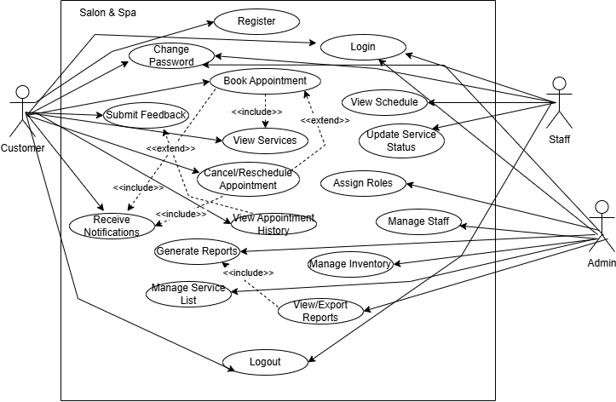

**4.2.1 Use Case Diagrams**

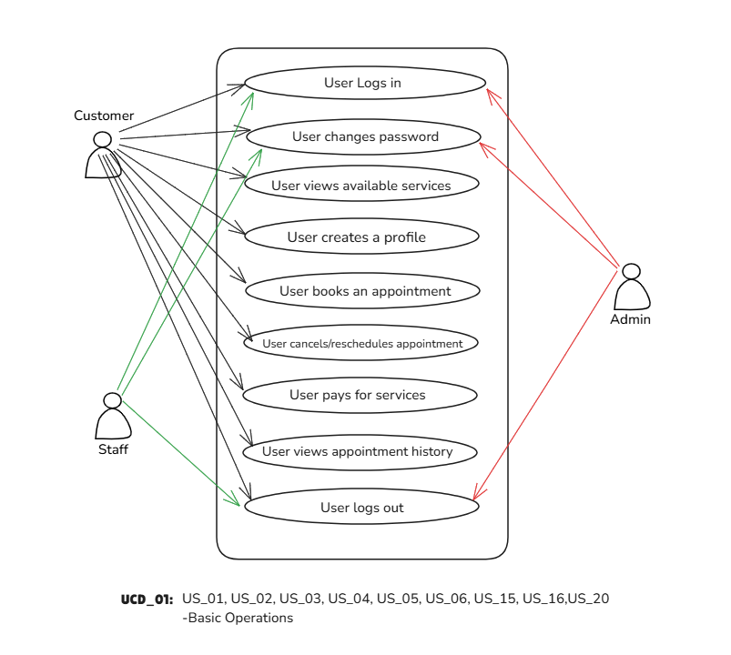

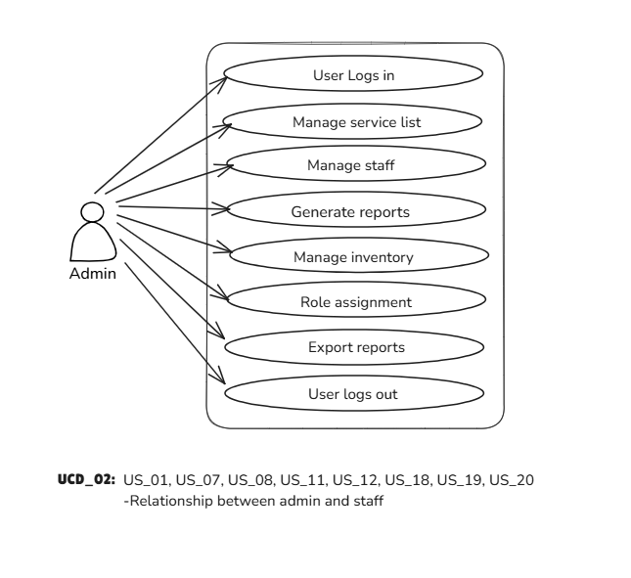

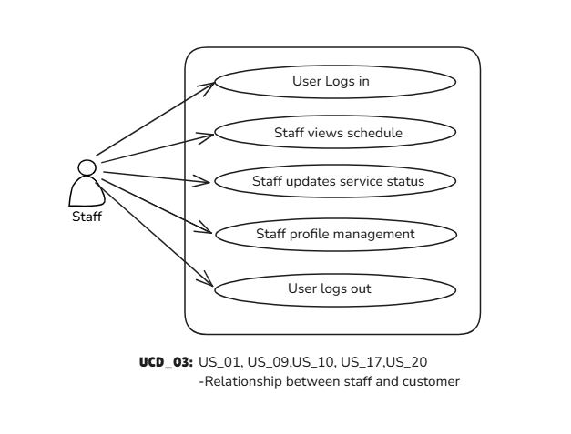

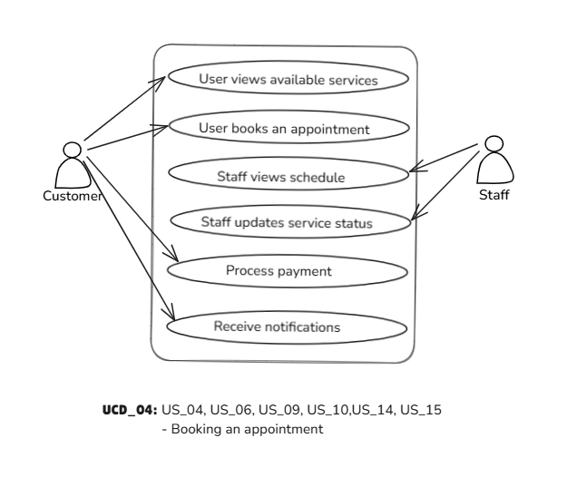

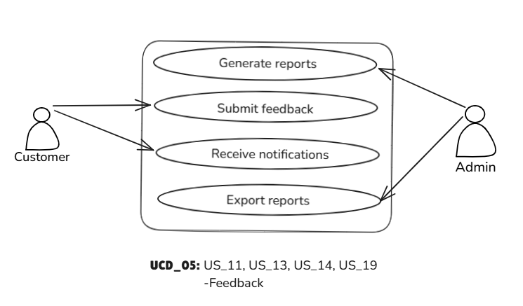

**4.2.2 Activity Diagrams**

**UC_01 – User logs in**

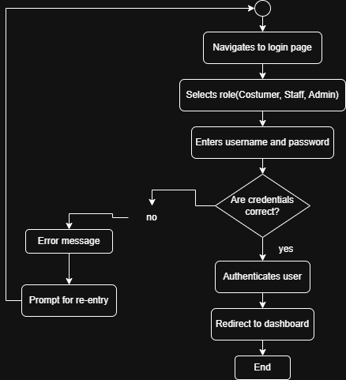

**UC_02 – Change password**

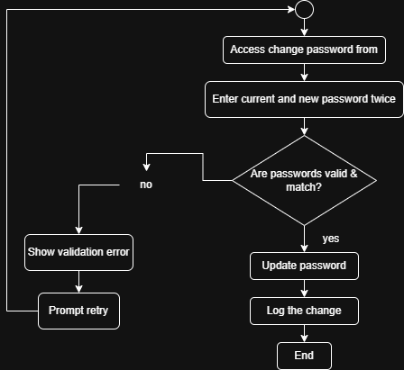

**UC_03 – Add a new customer**

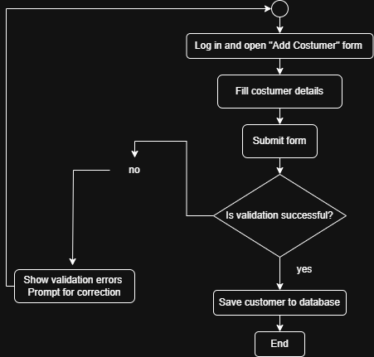

**UC_04 – Add a new staff member**

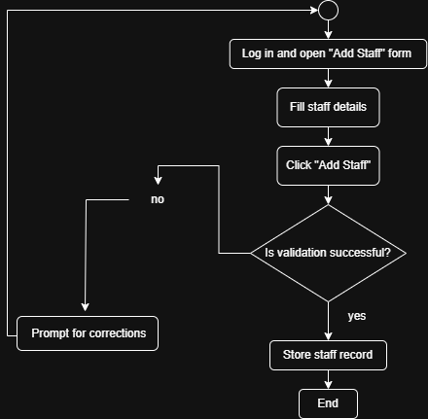

**UC_05 – View customer list**

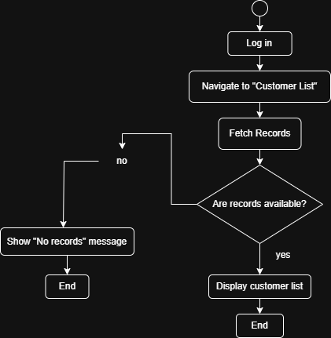

**UC_06 – View staff list**

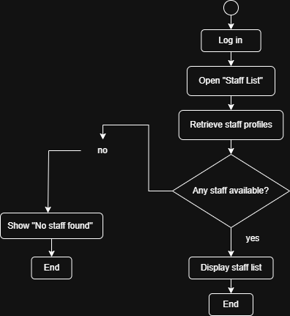

**UC_07: Book an Appointment**

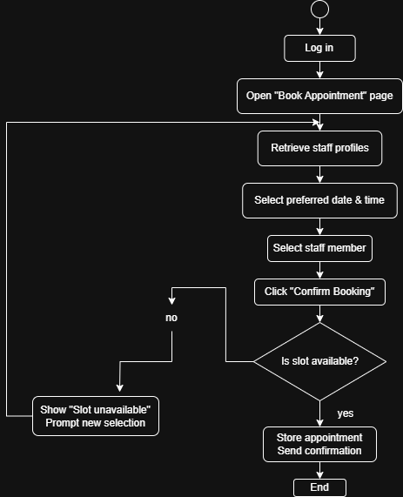

**UC Name: UC_08 – Manage Staff Schedule**

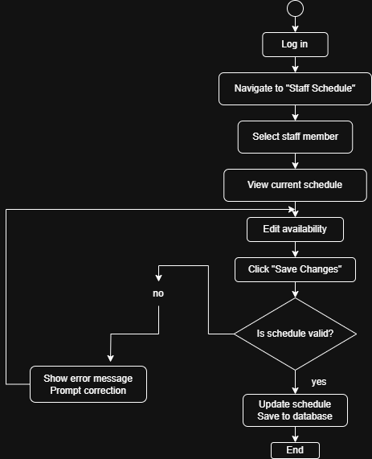

**UC_09 – Add a new customer from external file**

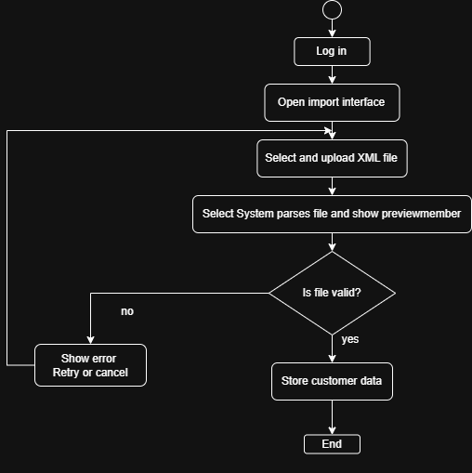

**UC_13 – Submit feedback**

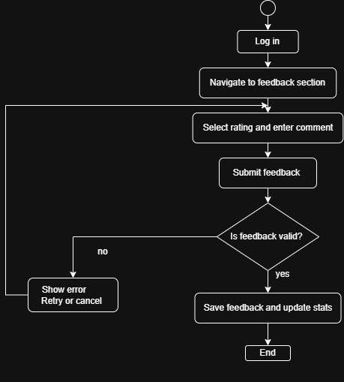

**4.3 ERD Schema**

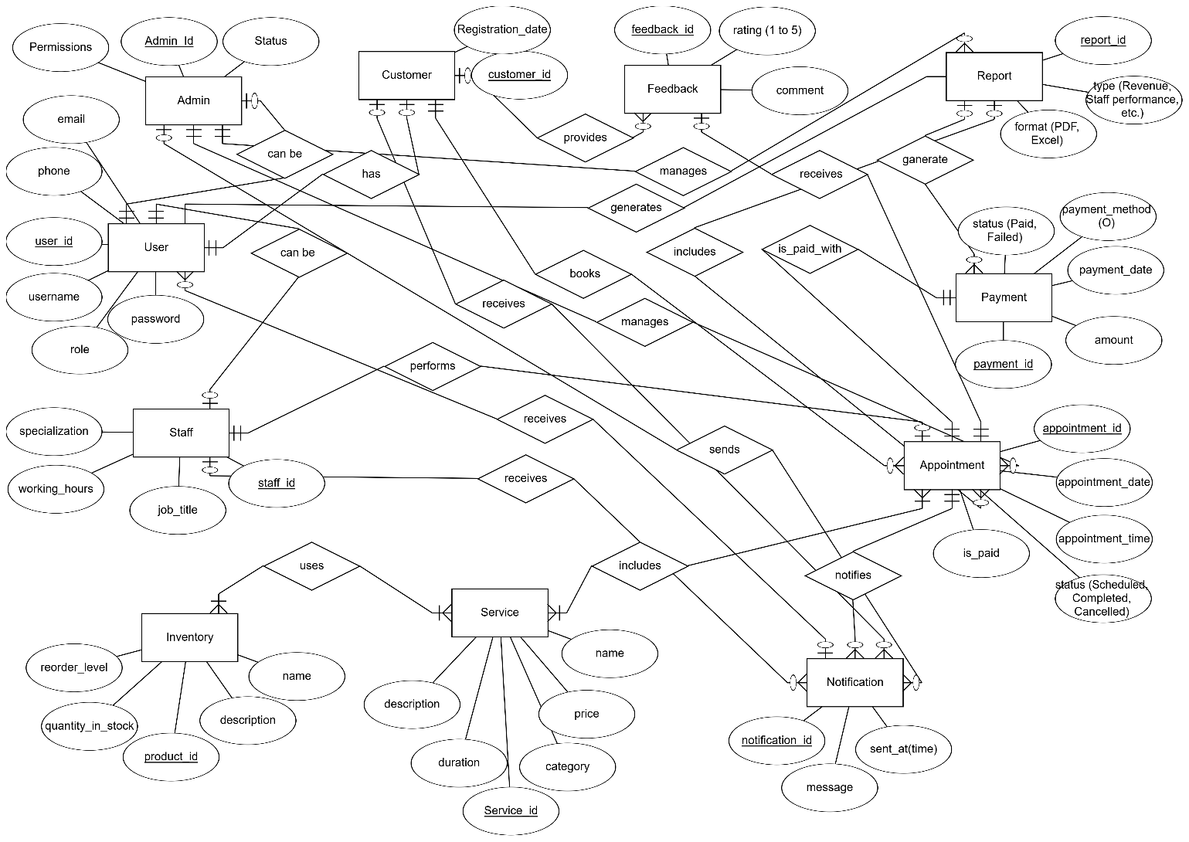

**4.3.1 Relational Schema**

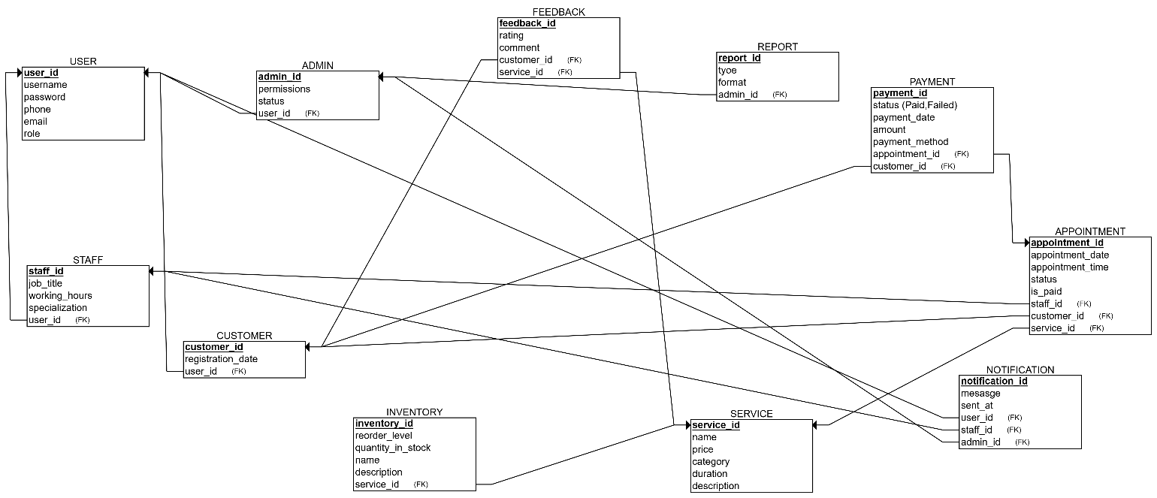

**4.4 Class Diag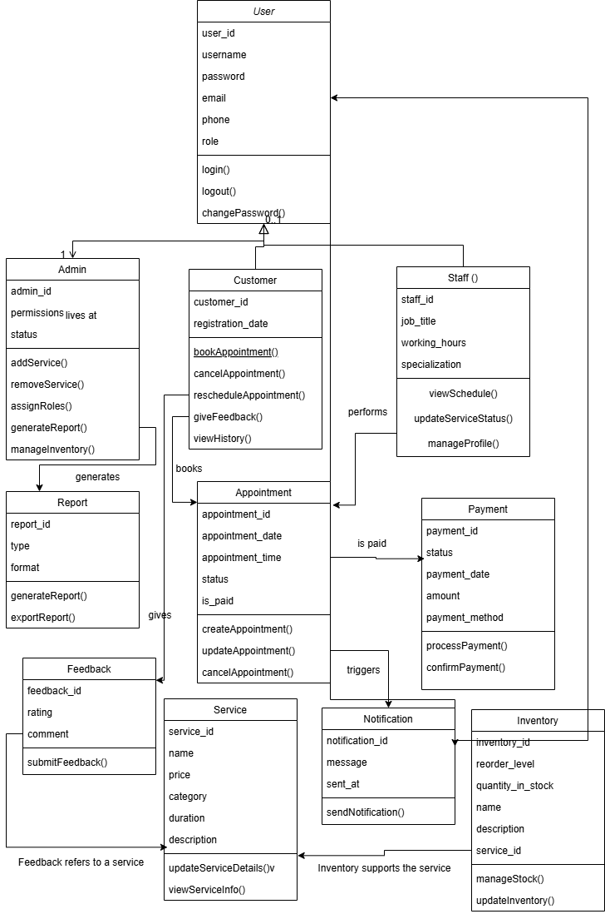ram**

**4.5 Component Diagram**

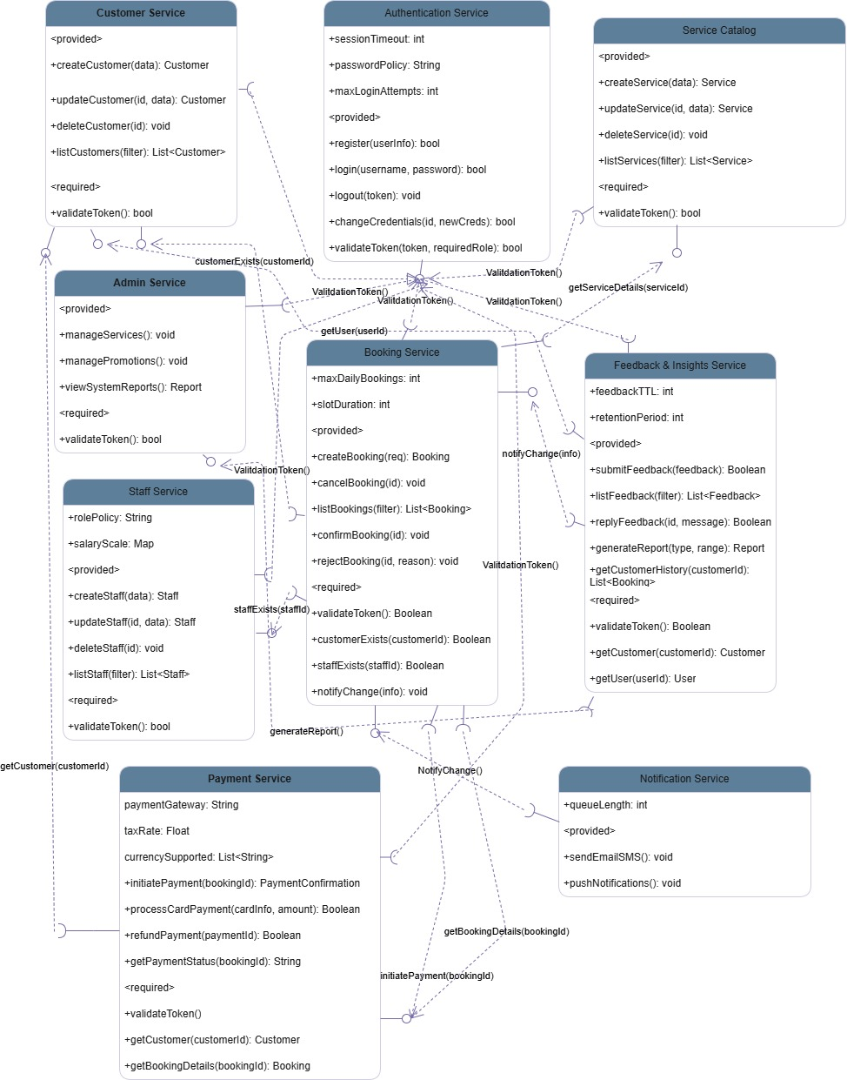

**4.6 Sequence Diagram**

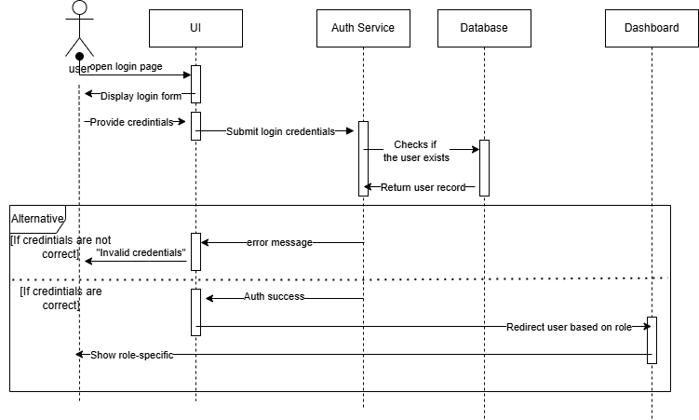**1.User LogIn**

**2.Role Assignment**

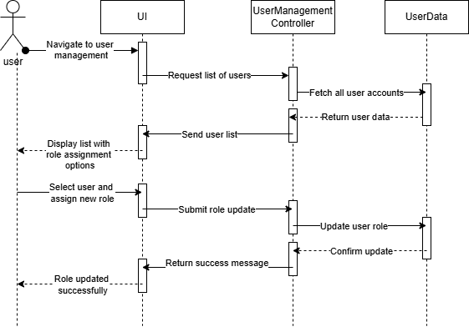

**3.Change Password**

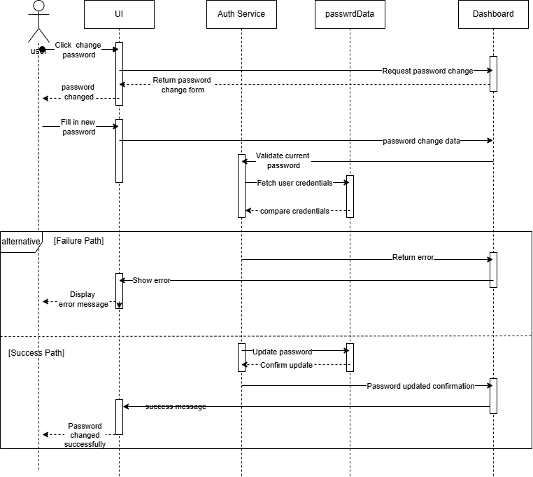

**4.Book Appointment**

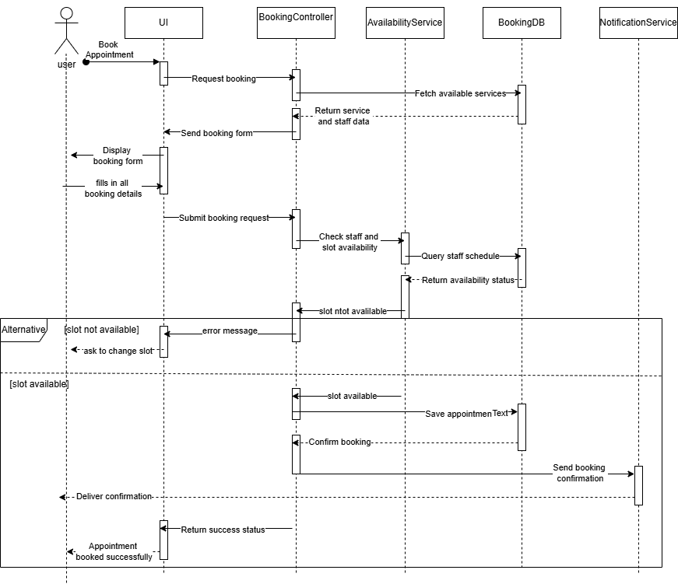

**5.Manage Staff**

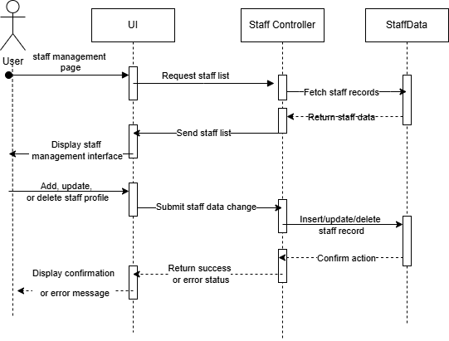

**6.Staff Updates Status**

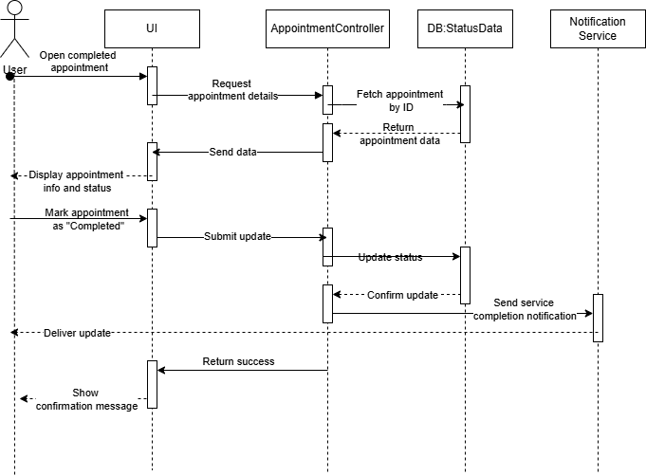

**19.Proceed payment**

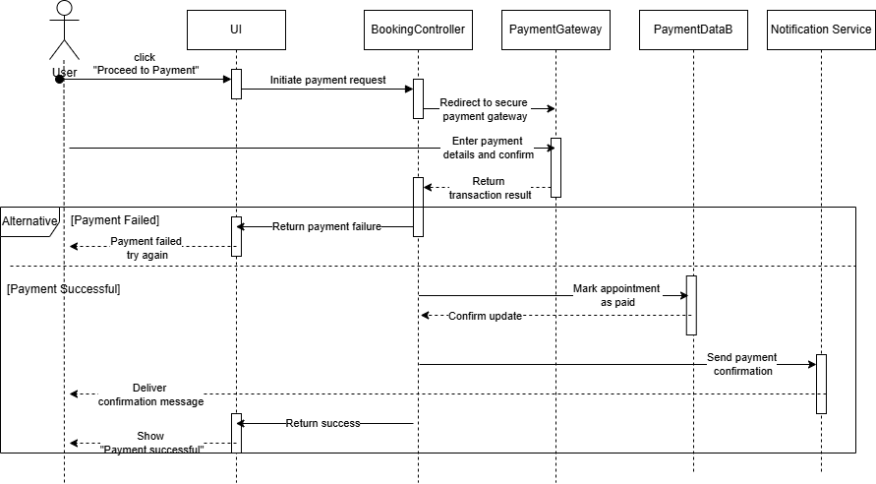

**UC_01 – User logs in & US_03 – Customer registration**

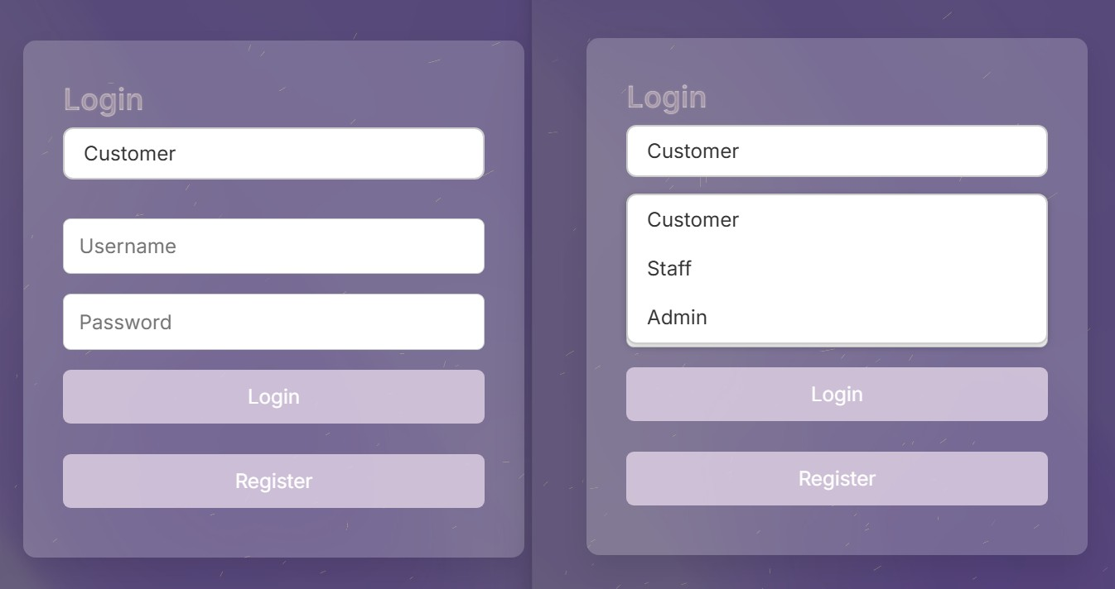

**US_02 – Change password**

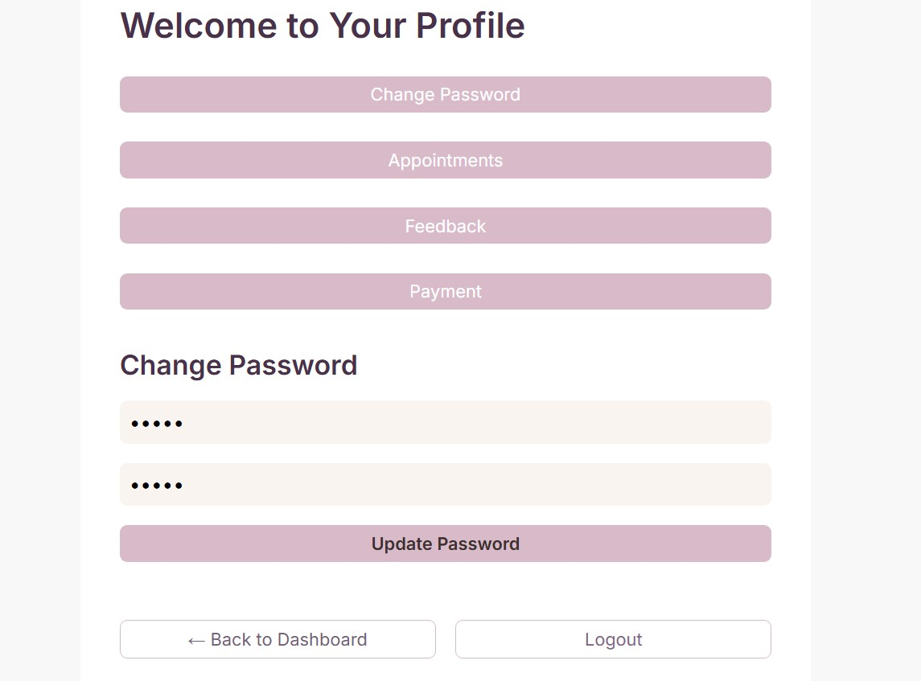

**US_04 – Book appointment**

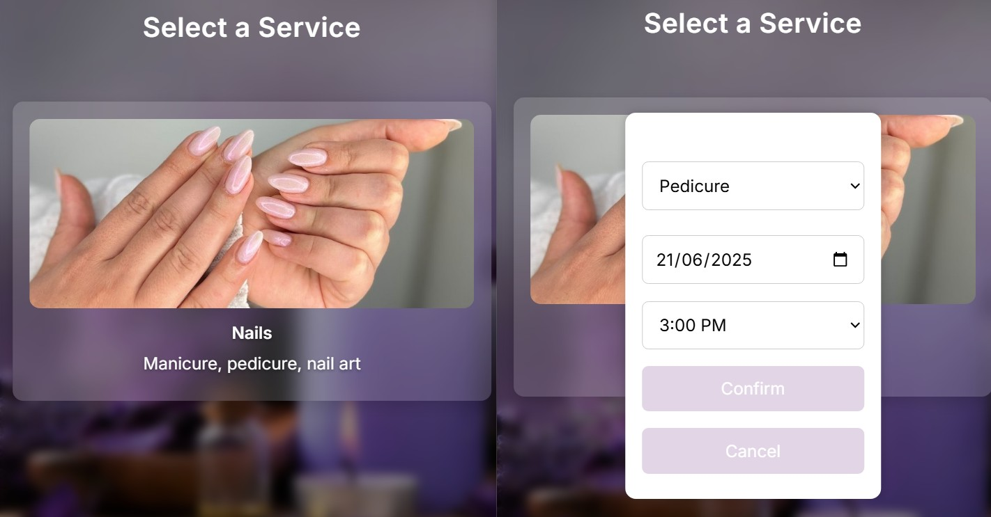

### ****US_05 – Cancel/Reschedule Appointment &**** US_15 – View appointment history

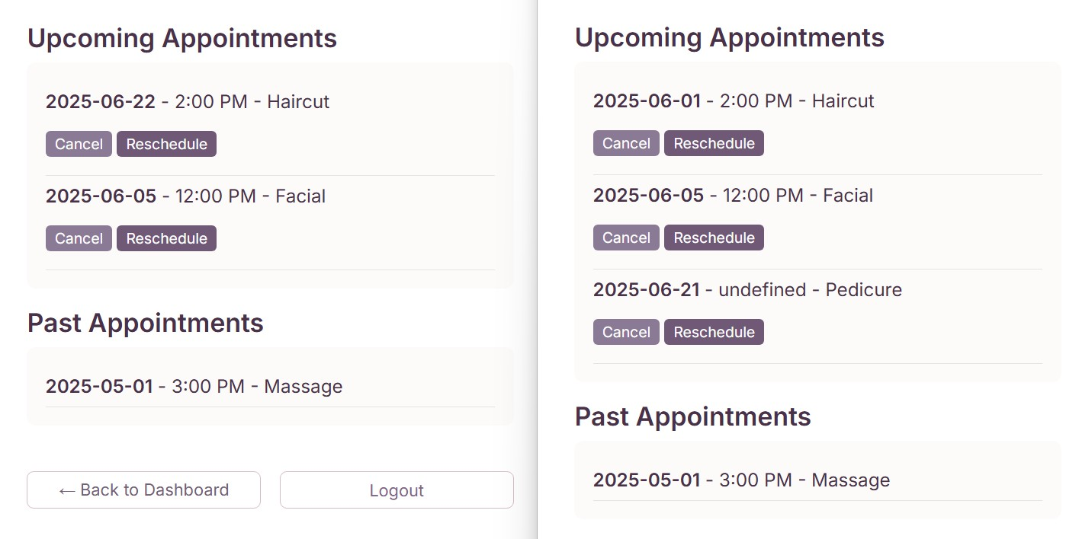

**US_06 – View available services**

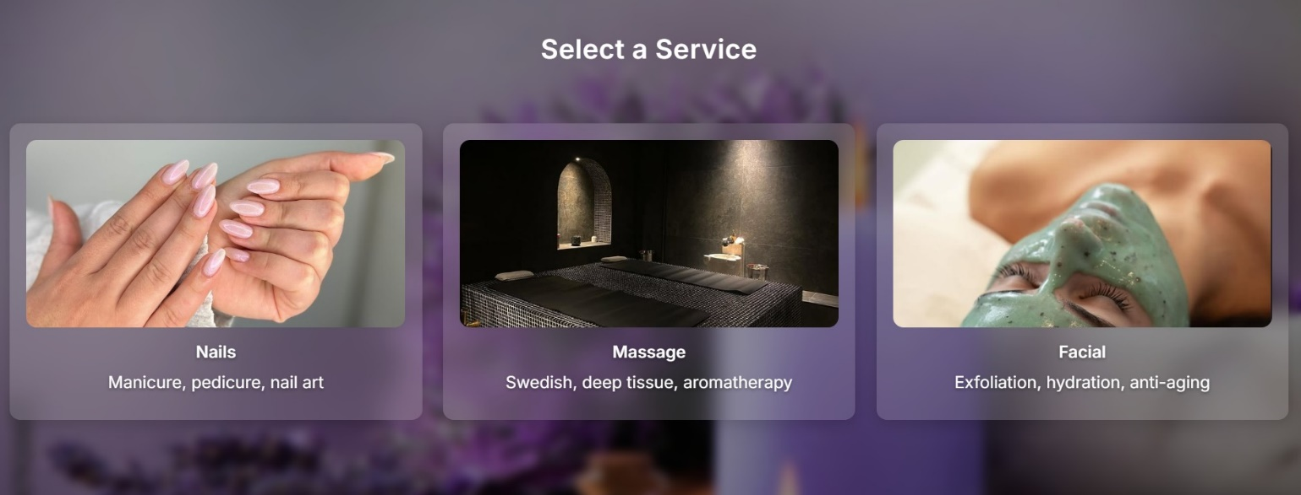

**US_07 – Admin Manages service list**

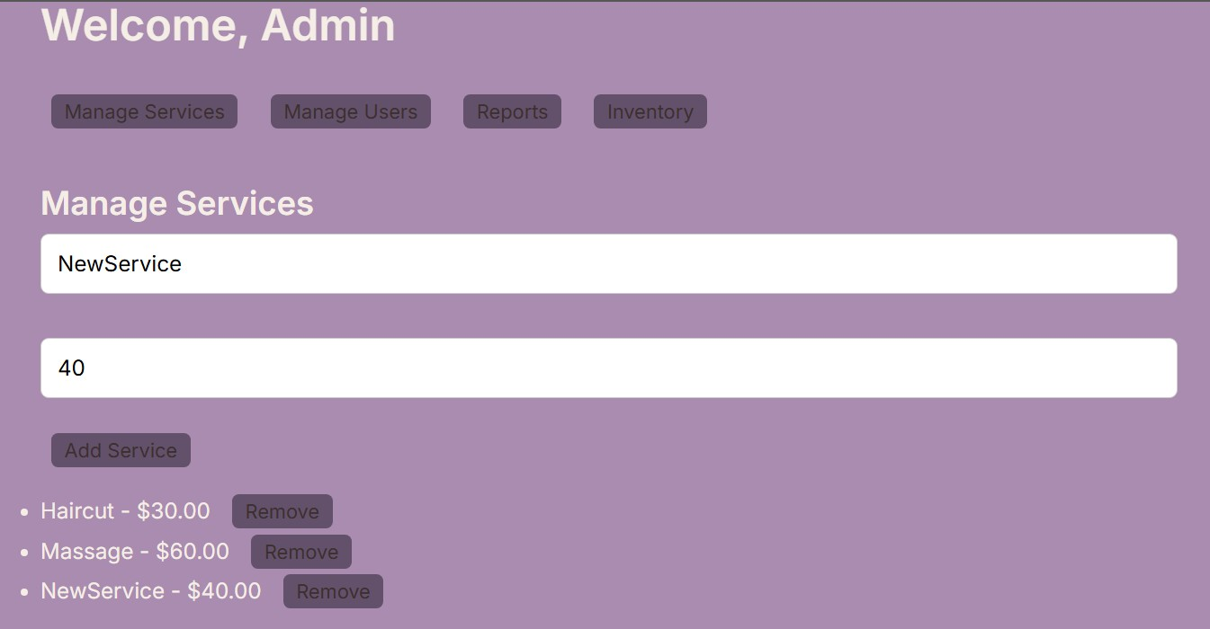

**US_08 – Admin manages staff**

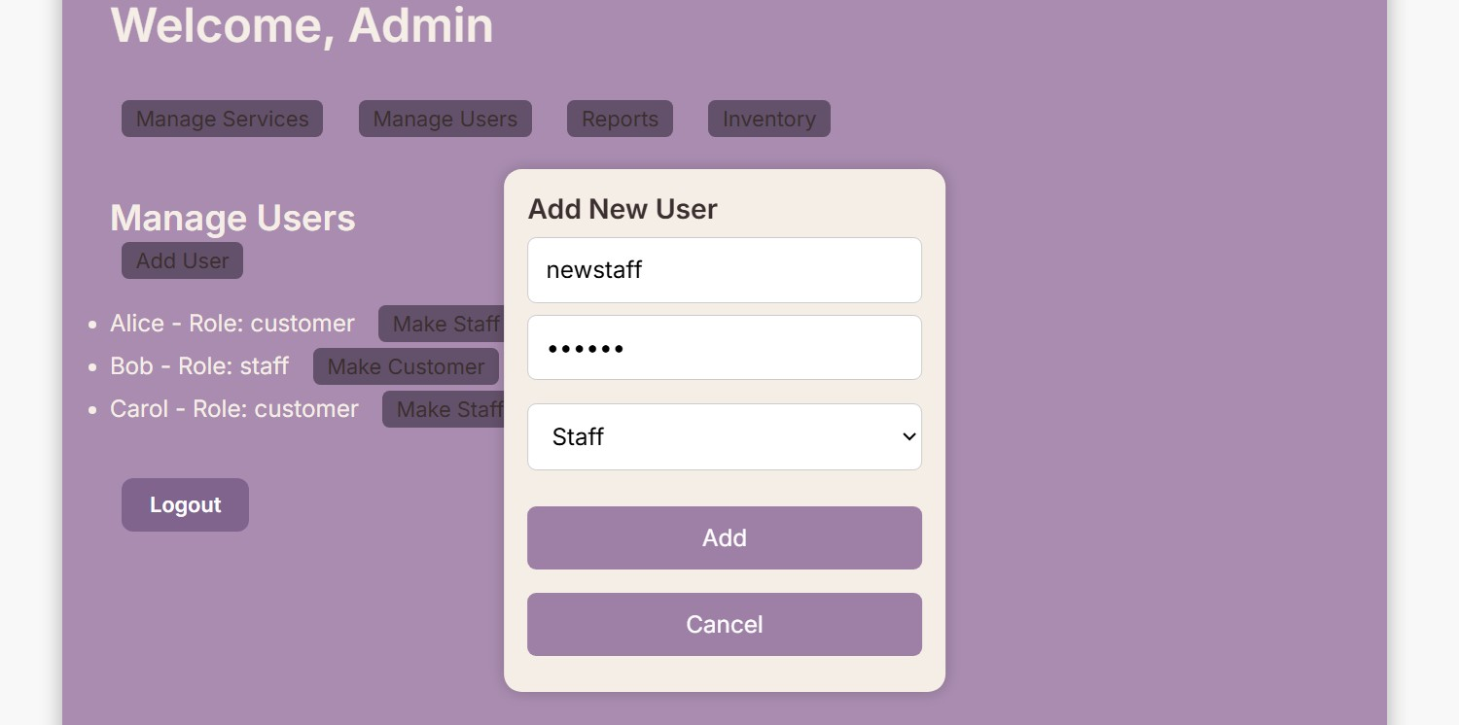

**US_09 – Staff views schedule & US_10 – Staff updates service status**

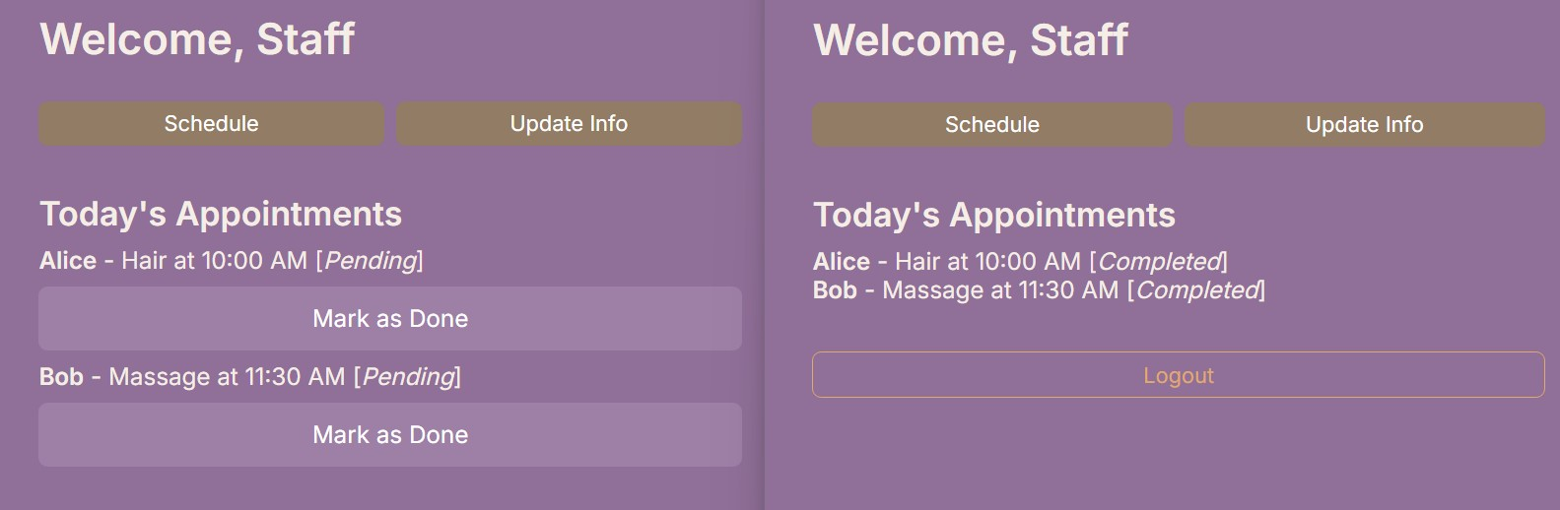

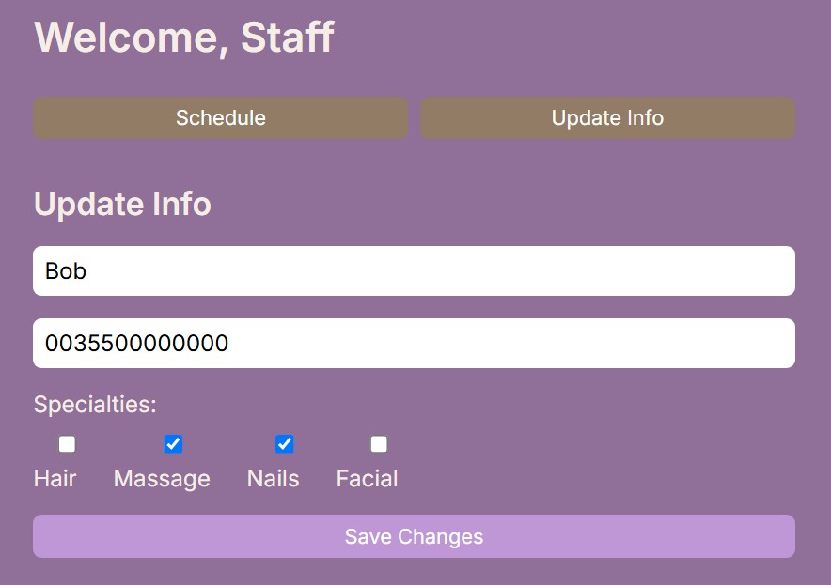

**US_11 – Admin generate reports**

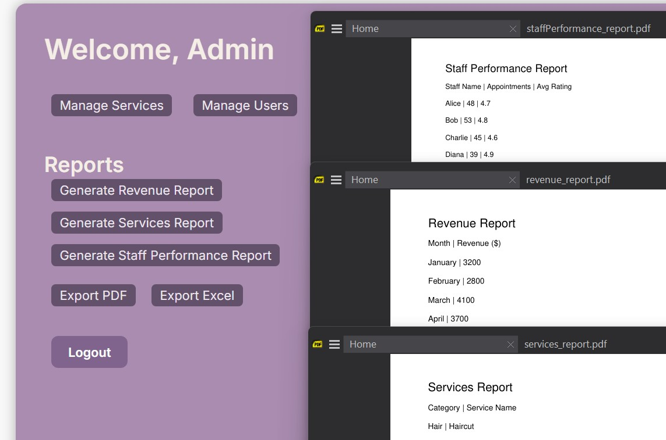

**US_12 – Admin manages inventory**

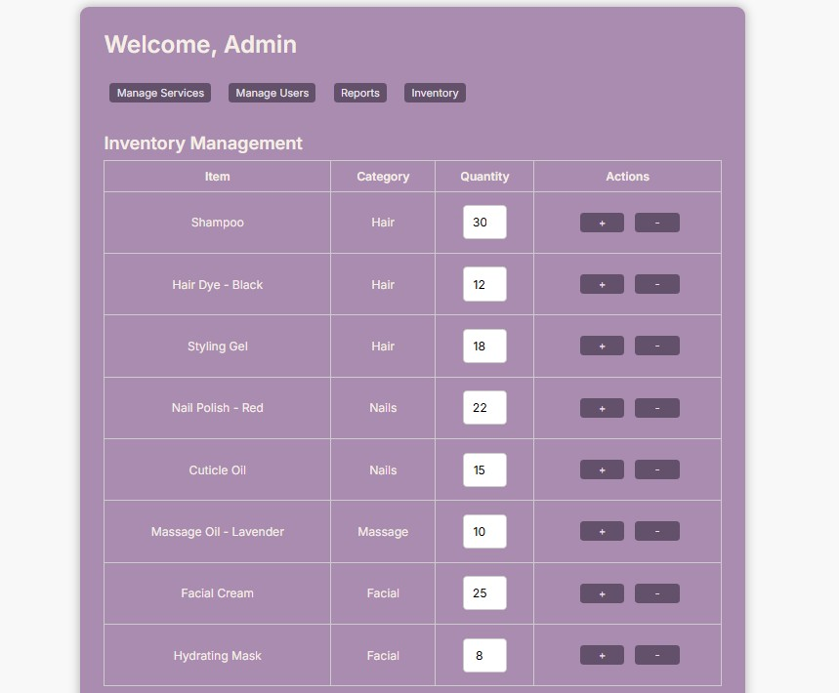

**US_13 – Submit feedback**

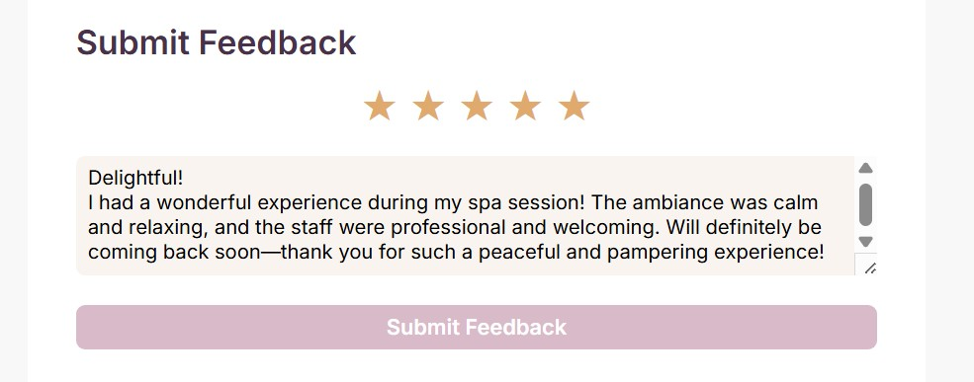

**US_14 – Receive notifications**

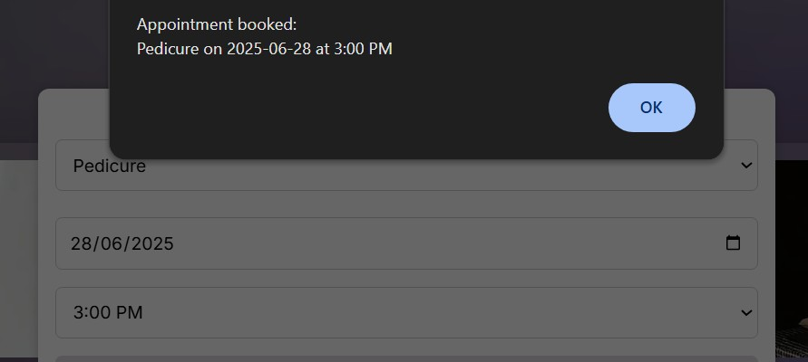

**US_16 – Admin role assignment**

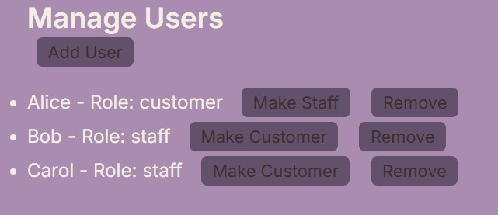

**US_17 – Admin views reports**

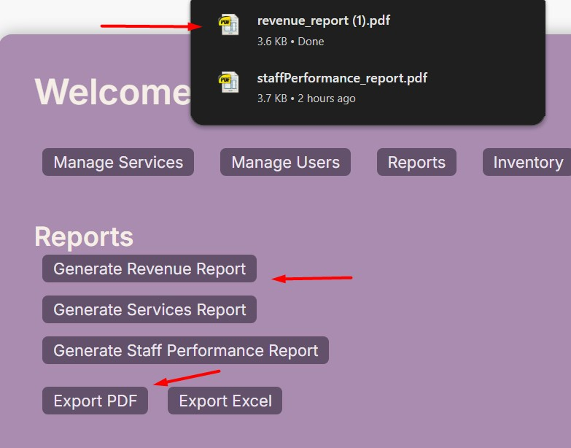

**US_18 – Logout**



**US_19 Process Payment**

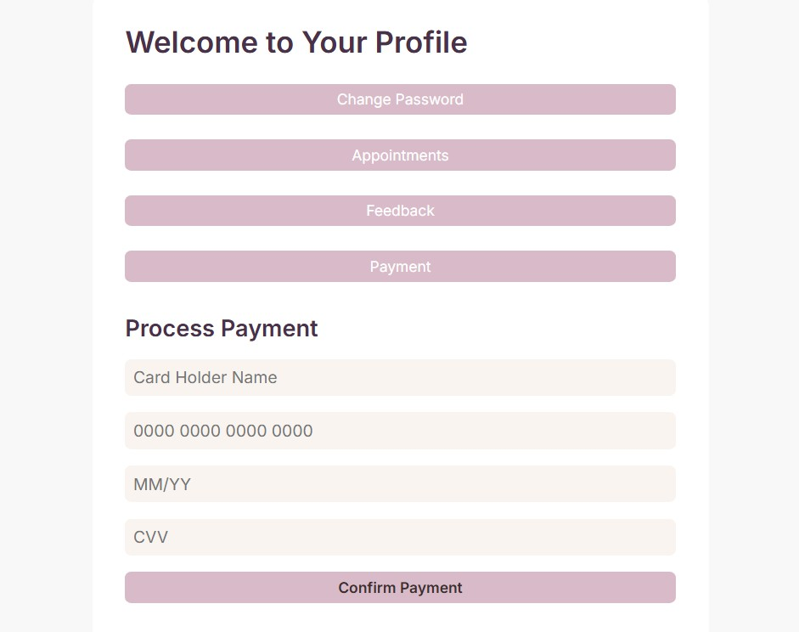

**6.Gantt Chart**

|  |  |  |  |
| --- | --- | --- | --- |
| Task ID | Task Name | Duration | Dependencies |
| 2 | Documentation | 20 days | 1 |
| 5 | Backend Development (.NET API) | 27 days | 2 |
| 6 | Frontend Development (React) | 15 days | 5 |
| 7 | Integration and Testing | 11 days | 5,6 |
| 8 | Bug Fixing and Improvements | 12 days | 7 |
| 9 | Deployment and Final Review | 4 days | 8 |
| 10 | Final Report Writing and Submission | 10 days | 2,9 |

**Documentation** ████████

**Backend Dev** ██████████████████████

**Frontend Dev** █████████████████████

**Integration &**

**Testing** ████████████

**Bug Fixing & ████████**

**Improvements**

**Deployment & ████**

**Final Review**

**Final Report ██████████**

**Writing**

**& Submission**